20220210 在 win10 安裝並使用 ffmpeg 影音轉檔程式
- 至[WINDOW版下載處 https://www.gyan.dev/ffmpeg/builds/]的release builds處下載ffmpeg-release-essentials.zip 77 MB並解開至d:\
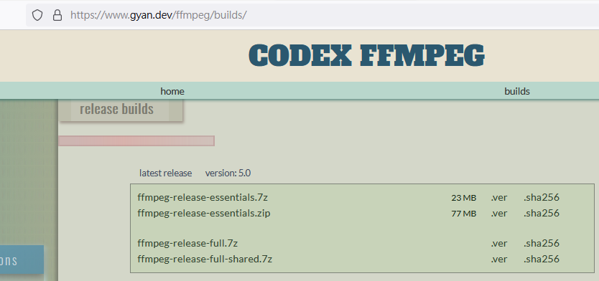

- 將如下解開資料夾D:\ffmpeg-5.0-essentials_build\ffmpeg-5.0-essentials_build\bin 中的ffmpeg.exe 和ffplay.exe 拷至d:\

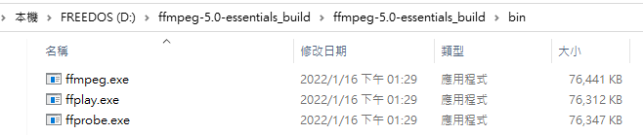

- 備妥一個i.mp4影片檔
(可將http://lfwiki.kmvs.km.edu.tw/lftree/uploads/output.mp4 下載為d:\i.mp4)
- 執行CMD(命令提示字元)並輸入如下ffmpeg指令，會出現本指令的版本、編譯組態與用法如下：
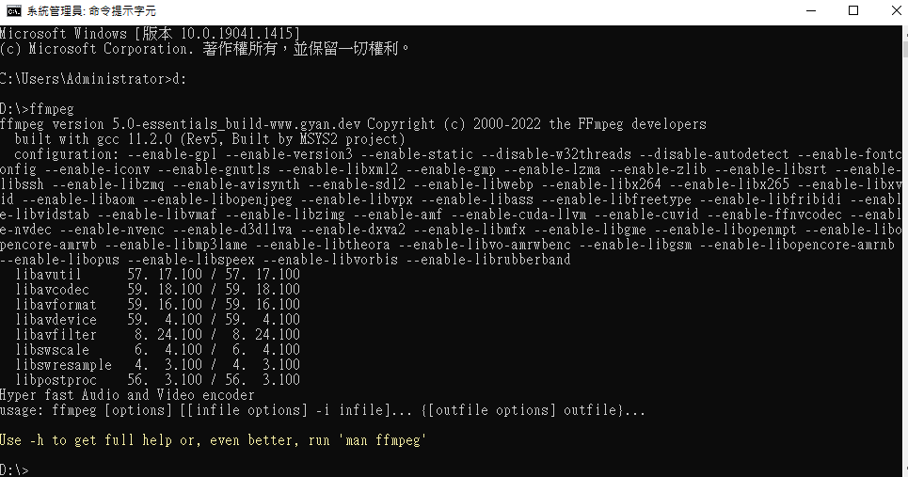
- 同(4)再執行ffmpeg –h ，會出現更多的使用說明如下。
D:\>ffmpeg -h
:
usage: ffmpeg [options] [[infile options] -i infile]... {[outfile options] outfile}...

Getting help:
-h -- print basic options
-h long -- print more options
-h full -- print all options (including all format and codec specific options, very long)
-h type=name -- print all options for the named decoder/encoder/demuxer/muxer/filter/bsf/protocol
See man ffmpeg for detailed description of the options.

Print help / information / capabilities:
-L show license
-h topic show help
-? topic show help
-help topic show help
--help topic show help
-version show version
-buildconf show build configuration
-formats show available formats
-muxers show available muxers
-demuxers show available demuxers
-devices show available devices
-codecs show available codecs
-decoders show available decoders
-encoders show available encoders
-bsfs show available bit stream filters
-protocols show available protocols
-filters show available filters
-pix_fmts show available pixel formats
-layouts show standard channel layouts
-sample_fmts show available audio sample formats
-dispositions show available stream dispositions
-colors show available color names
-sources device list sources of the input device
-sinks device list sinks of the output device
-hwaccels show available HW acceleration methods

Global options (affect whole program instead of just one file):
-loglevel loglevel set logging level
-v loglevel set logging level
-report generate a report
-max_alloc bytes set maximum size of a single allocated block
-y overwrite output files
-n never overwrite output files
-ignore_unknown Ignore unknown stream types
-filter_threads number of non-complex filter threads
-filter_complex_threads number of threads for -filter_complex
-stats print progress report during encoding
-max_error_rate maximum error rate ratio of decoding errors (0.0: no errors, 1.0: 100% errors) above which ffmpeg returns an error instead of success.
-vol volume change audio volume (256=normal)

Per-file main options:
-f fmt force format
-c codec codec name
-codec codec codec name
-pre preset preset name
-map_metadata outfile[,metadata]:infile[,metadata] set metadata information of outfile from infile
-t duration record or transcode "duration" seconds of audio/video
-to time_stop record or transcode stop time
-fs limit_size set the limit file size in bytes
-ss time_off set the start time offset
-sseof time_off set the start time offset relative to EOF
-seek_timestamp enable/disable seeking by timestamp with -ss
-timestamp time set the recording timestamp ('now' to set the current time)
-metadata string=string add metadata
-program title=string:st=number... add program with specified streams
-target type specify target file type ("vcd", "svcd", "dvd", "dv" or "dv50" with optional prefixes "pal-", "ntsc-" or "film-")
-apad audio pad
-frames number set the number of frames to output
-filter filter_graph set stream filtergraph
-filter_script filename read stream filtergraph description from a file
-reinit_filter reinit filtergraph on input parameter changes
-discard discard
-disposition disposition

Video options:
-vframes number set the number of video frames to output
-r rate set frame rate (Hz value, fraction or abbreviation)
-fpsmax rate set max frame rate (Hz value, fraction or abbreviation)
-s size set frame size (WxH or abbreviation)
-aspect aspect set aspect ratio (4:3, 16:9 or 1.3333, 1.7777)
-vn disable video
-vcodec codec force video codec ('copy' to copy stream)
-timecode hh:mm:ss[:;.]ff set initial TimeCode value.
-pass n select the pass number (1 to 3)
-vf filter_graph set video filters
-ab bitrate audio bitrate (please use -b:a)
-b bitrate video bitrate (please use -b:v)
-dn disable data

Audio options:
-aframes number set the number of audio frames to output
-aq quality set audio quality (codec-specific)
-ar rate set audio sampling rate (in Hz)
-ac channels set number of audio channels
-an disable audio
-acodec codec force audio codec ('copy' to copy stream)
-vol volume change audio volume (256=normal)
-af filter_graph set audio filters

Subtitle options:
-s size set frame size (WxH or abbreviation)
-sn disable subtitle
-scodec codec force subtitle codec ('copy' to copy stream)
-stag fourcc/tag force subtitle tag/fourcc
-fix_sub_duration fix subtitles duration
-canvas_size size set canvas size (WxH or abbreviation)
-spre preset set the subtitle options to the indicated preset

- 執行ffmpeg -i i.mp4 -c:v libx264 -c:a aac o.mp4
以影像編碼採用 H.264 、音訊編碼採用 AAC將 i.mp4 轉為 o.mp4，
並再執行DIR *.MP4 結果如下：
註1: 進階音訊編碼（英語：Advanced Audio Coding，AAC）是有損音訊壓縮的專利數位音訊編碼標準，由Fraunhofer IIS、杜比實驗室、貝爾實驗室、Sony、Nokia等公司共同開發。
註2: H.264，也稱作MPEG-4 AVC（Advanced Video Codec，高級影像編碼），是一種視訊壓縮標準，同時也是一種被廣泛使用的高精度影像的錄製、壓縮和發佈格式，採基於運動補償的視訊編碼標準。
D:\>ffmpeg -i i.mp4 -c:v libx264 -c:a aac o.mp4
:
Input #0, mov,mp4,m4a,3gp,3g2,mj2, from 'i.mp4':
Metadata:
major_brand : isom
minor_version : 512
compatible_brands: isomiso2avc1mp41
encoder : Lavf56.40.101
Duration: 00:00:23.04, start: 0.000000, bitrate: 2346 kb/s
Stream #0:0[0x1](eng): Video: h264 (High) (avc1 / 0x31637661), yuvj420p(pc, progressive), 1920x1080 [SAR 1:1 DAR 16:9], 2070 kb/s, 59.94 fps, 59.94 tbr, 60k tbn (default)
Metadata:
handler_name : VideoHandler
vendor_id : [0][0][0][0]
Stream #0:1[0x2](eng): Audio: aac (LC) (mp4a / 0x6134706D), 48000 Hz, stereo, fltp, 262 kb/s (default)
Metadata:
handler_name : SoundHandler
vendor_id : [0][0][0][0]
Stream mapping:
Stream #0:0 -> #0:0 (h264 (native) -> h264 (libx264))
Stream #0:1 -> #0:1 (aac (native) -> aac (native))
Press [q] to stop, [?] for help
[libx264 @ 000001d9b5562e80] using SAR=1/1
[libx264 @ 000001d9b5562e80] using cpu capabilities: MMX2 SSE2Fast SSSE3 SSE4.2 AVX FMA3 BMI2 AVX2
[libx264 @ 000001d9b5562e80] profile High, level 4.2, 4:2:0, 8-bit
[libx264 @ 000001d9b5562e80] 264 - core 164 r3081 19856cc - H.264/MPEG-4 AVC codec - Copyleft 2003-2021 - http://www.videolan.org/x264.html - options: cabac=1 ref=3 deblock=1:0:0 analyse=0x3:0x113 me=hex subme=7 psy=1 psy_rd=1.00:0.00 mixed_ref=1 me_range=16 chroma_me=1 trellis=1 8x8dct=1 cqm=0 deadzone=21,11 fast_pskip=1 chroma_qp_offset=-2 threads=6 lookahead_threads=1 sliced_threads=0 nr=0 decimate=1 interlaced=0 bluray_compat=0 constrained_intra=0 bframes=3 b_pyramid=2 b_adapt=1 b_bias=0 direct=1 weightb=1 open_gop=0 weightp=2 keyint=250 keyint_min=25 scenecut=40 intra_refresh=0 rc_lookahead=40 rc=crf mbtree=1 crf=23.0 qcomp=0.60 qpmin=0 qpmax=69 qpstep=4 ip_ratio=1.40 aq=1:1.00
Output #0, mp4, to 'o.mp4':
Metadata:
major_brand : isom
minor_version : 512
compatible_brands: isomiso2avc1mp41
encoder : Lavf59.16.100
Stream #0:0(eng): Video: h264 (avc1 / 0x31637661), yuvj420p(pc, progressive), 1920x1080 [SAR 1:1 DAR 16:9], q=2-31, 59.94 fps, 60k tbn (default)
Metadata:
handler_name : VideoHandler
vendor_id : [0][0][0][0]
encoder : Lavc59.18.100 libx264
Side data:
cpb: bitrate max/min/avg: 0/0/0 buffer size: 0 vbv_delay: N/A
Stream #0:1(eng): Audio: aac (LC) (mp4a / 0x6134706D), 48000 Hz, stereo, fltp, 128 kb/s (default)
Metadata:
handler_name : SoundHandler
vendor_id : [0][0][0][0]
encoder : Lavc59.18.100 aac
frame= 1381 fps= 42 q=-1.0 Lsize= 14995kB time=00:00:23.01 bitrate=5337.5kbits/s speed=0.701x
video:14591kB audio:367kB subtitle:0kB other streams:0kB global headers:0kB muxing overhead: 0.249055%
[libx264 @ 000001d9b5562e80] frame I:7 Avg QP:22.34 size:168652
[libx264 @ 000001d9b5562e80] frame P:610 Avg QP:25.42 size: 17810
[libx264 @ 000001d9b5562e80] frame B:764 Avg QP:30.29 size: 3790
[libx264 @ 000001d9b5562e80] consecutive B-frames: 4.7% 64.0% 1.7% 29.5%
[libx264 @ 000001d9b5562e80] mb I I16..4: 6.0% 77.6% 16.4%
[libx264 @ 000001d9b5562e80] mb P I16..4: 0.5% 3.1% 0.1% P16..4: 33.5% 6.4% 3.5% 0.0% 0.0% skip:52.8%
[libx264 @ 000001d9b5562e80] mb B I16..4: 0.0% 0.2% 0.0% B16..8: 33.5% 0.9% 0.2% direct: 0.3% skip:64.8% L0:41.1% L1:57.5% BI: 1.4%
[libx264 @ 000001d9b5562e80] 8x8 transform intra:81.2% inter:82.3%
[libx264 @ 000001d9b5562e80] coded y,uvDC,uvAC intra: 51.2% 23.6% 1.2% inter: 6.7% 1.5% 0.0%
[libx264 @ 000001d9b5562e80] i16 v,h,dc,p: 30% 38% 19% 13%
[libx264 @ 000001d9b5562e80] i8 v,h,dc,ddl,ddr,vr,hd,vl,hu: 23% 15% 33% 4% 5% 5% 5% 5% 5%
[libx264 @ 000001d9b5562e80] i4 v,h,dc,ddl,ddr,vr,hd,vl,hu: 26% 16% 16% 6% 8% 8% 8% 6% 6%
[libx264 @ 000001d9b5562e80] i8c dc,h,v,p: 79% 10% 9% 1%
[libx264 @ 000001d9b5562e80] Weighted P-Frames: Y:7.5% UV:1.0%
[libx264 @ 000001d9b5562e80] ref P L0: 75.3% 17.5% 6.2% 1.0% 0.1%
[libx264 @ 000001d9b5562e80] ref B L0: 96.1% 3.7% 0.2%
[libx264 @ 000001d9b5562e80] ref B L1: 99.8% 0.2%
[libx264 @ 000001d9b5562e80] kb/s:5187.65
[aac @ 000001d9b5583840] Qavg: 476.761

D:\>DIR *.MP4
:
D:\ 的目錄

2022/02/11 下午 02:02 6,757,887 i.mp4
2022/02/11 下午 02:17 15,354,465 o.mp4
2 個檔案 22,112,352 位元組

- 同(6)增加如下-b:v 1M -b:a 256k 選項來調整bitRate(位元率)，
執行ffmpeg -i i.mp4 -c:v libx264 -c:a aac -b:v 1M -b:a 256k o.mp4
並再執行DIR *.MP4，結果如下(o.mp4檔案已降為 3.6 MB，可是畫質很差)：
D:\>ffmpeg -i i.mp4 -c:v libx264 -c:a aac -b:v 1M -b:a 256k o.mp4
:
Input #0, mov,mp4,m4a,3gp,3g2,mj2, from 'i.mp4':
Metadata:
major_brand : isom
minor_version : 512
compatible_brands: isomiso2avc1mp41
encoder : Lavf56.40.101
Duration: 00:00:23.04, start: 0.000000, bitrate: 2346 kb/s
Stream #0:0[0x1](eng): Video: h264 (High) (avc1 / 0x31637661), yuvj420p(pc, progressive), 1920x1080 [SAR 1:1 DAR 16:9], 2070 kb/s, 59.94 fps, 59.94 tbr, 60k tbn (default)
Metadata:
handler_name : VideoHandler
vendor_id : [0][0][0][0]
Stream #0:1[0x2](eng): Audio: aac (LC) (mp4a / 0x6134706D), 48000 Hz, stereo, fltp, 262 kb/s (default)
Metadata:
handler_name : SoundHandler
vendor_id : [0][0][0][0]
File 'o.mp4' already exists. Overwrite? [y/N] Y
Stream mapping:
Stream #0:0 -> #0:0 (h264 (native) -> h264 (libx264))
Stream #0:1 -> #0:1 (aac (native) -> aac (native))
Press [q] to stop, [?] for help
[libx264 @ 000001b589b831c0] using SAR=1/1
[libx264 @ 000001b589b831c0] using cpu capabilities: MMX2 SSE2Fast SSSE3 SSE4.2 AVX FMA3 BMI2 AVX2
[libx264 @ 000001b589b831c0] profile High, level 4.2, 4:2:0, 8-bit
[libx264 @ 000001b589b831c0] 264 - core 164 r3081 19856cc - H.264/MPEG-4 AVC codec - Copyleft 2003-2021 - http://www.videolan.org/x264.html - options: cabac=1 ref=3 deblock=1:0:0 analyse=0x3:0x113 me=hex subme=7 psy=1 psy_rd=1.00:0.00 mixed_ref=1 me_range=16 chroma_me=1 trellis=1 8x8dct=1 cqm=0 deadzone=21,11 fast_pskip=1 chroma_qp_offset=-2 threads=6 lookahead_threads=1 sliced_threads=0 nr=0 decimate=1 interlaced=0 bluray_compat=0 constrained_intra=0 bframes=3 b_pyramid=2 b_adapt=1 b_bias=0 direct=1 weightb=1 open_gop=0 weightp=2 keyint=250 keyint_min=25 scenecut=40 intra_refresh=0 rc_lookahead=40 rc=abr mbtree=1 bitrate=1000 ratetol=1.0 qcomp=0.60 qpmin=0 qpmax=69 qpstep=4 ip_ratio=1.40 aq=1:1.00
Output #0, mp4, to 'o.mp4':
Metadata:
major_brand : isom
minor_version : 512
compatible_brands: isomiso2avc1mp41
encoder : Lavf59.16.100
Stream #0:0(eng): Video: h264 (avc1 / 0x31637661), yuvj420p(pc, progressive), 1920x1080 [SAR 1:1 DAR 16:9], q=2-31, 1000 kb/s, 59.94 fps, 60k tbn (default)
Metadata:
handler_name : VideoHandler
vendor_id : [0][0][0][0]
encoder : Lavc59.18.100 libx264
Side data:
cpb: bitrate max/min/avg: 0/0/1000000 buffer size: 0 vbv_delay: N/A
Stream #0:1(eng): Audio: aac (LC) (mp4a / 0x6134706D), 48000 Hz, stereo, fltp, 256 kb/s (default)
Metadata:
handler_name : SoundHandler
vendor_id : [0][0][0][0]
encoder : Lavc59.18.100 aac
frame= 1381 fps= 49 q=-1.0 Lsize= 3552kB time=00:00:23.01 bitrate=1264.3kbits/s speed=0.811x
video:2821kB audio:694kB subtitle:0kB other streams:0kB global headers:0kB muxing overhead: 1.059906%
[libx264 @ 000001b589b831c0] frame I:7 Avg QP:39.79 size: 40197
[libx264 @ 000001b589b831c0] frame P:610 Avg QP:44.04 size: 2919
[libx264 @ 000001b589b831c0] frame B:764 Avg QP:49.34 size: 1081
[libx264 @ 000001b589b831c0] consecutive B-frames: 4.7% 64.0% 1.7% 29.5%
[libx264 @ 000001b589b831c0] mb I I16..4: 14.3% 77.9% 7.8%
[libx264 @ 000001b589b831c0] mb P I16..4: 0.6% 1.7% 0.0% P16..4: 15.7% 0.3% 0.4% 0.0% 0.0% skip:81.5%
[libx264 @ 000001b589b831c0] mb B I16..4: 0.0% 0.0% 0.0% B16..8: 18.2% 0.0% 0.0% direct: 0.0% skip:81.8% L0:28.9% L1:71.0% BI: 0.0%
[libx264 @ 000001b589b831c0] final ratefactor: 40.88
[libx264 @ 000001b589b831c0] 8x8 transform intra:75.2% inter:97.2%
[libx264 @ 000001b589b831c0] coded y,uvDC,uvAC intra: 19.6% 12.9% 0.1% inter: 0.7% 0.3% 0.0%
[libx264 @ 000001b589b831c0] i16 v,h,dc,p: 39% 36% 11% 14%
[libx264 @ 000001b589b831c0] i8 v,h,dc,ddl,ddr,vr,hd,vl,hu: 11% 7% 68% 2% 3% 2% 3% 2% 2%
[libx264 @ 000001b589b831c0] i4 v,h,dc,ddl,ddr,vr,hd,vl,hu: 21% 17% 20% 8% 9% 7% 7% 5% 4%
[libx264 @ 000001b589b831c0] i8c dc,h,v,p: 95% 3% 2% 0%
[libx264 @ 000001b589b831c0] Weighted P-Frames: Y:7.5% UV:1.0%
[libx264 @ 000001b589b831c0] ref P L0: 78.7% 6.5% 11.2% 3.4% 0.2%
[libx264 @ 000001b589b831c0] ref B L0: 96.3% 3.4% 0.3%
[libx264 @ 000001b589b831c0] ref B L1: 99.6% 0.4%
[libx264 @ 000001b589b831c0] kb/s:1002.77
[aac @ 000001b58a0aa040] Qavg: 9373.473

D:\>DIR *.MP4
:
2022/02/11 下午 02:02 6,757,887 i.mp4
2022/02/11 下午 02:29 3,637,048 o.mp4
2 個檔案 10,394,935 位元組

- 同(7)改如下-b:v 4M選項來調整bitRate(位元率)，
執行ffmpeg -i i.mp4 -c:v libx264 -c:a aac -b:v 4M -b:a 256k o.mp4
並再執行DIR *.MP4，結果如下(o.mp4檔案昇為 13MB，可是畫質不會變更好)：
D:\>ffmpeg -i i.mp4 -c:v libx264 -c:a aac -b:v 4M -b:a 256k o.mp4
:
Input #0, mov,mp4,m4a,3gp,3g2,mj2, from 'i.mp4':
Metadata:
major_brand : isom
minor_version : 512
compatible_brands: isomiso2avc1mp41
encoder : Lavf56.40.101
Duration: 00:00:23.04, start: 0.000000, bitrate: 2346 kb/s
Stream #0:0[0x1](eng): Video: h264 (High) (avc1 / 0x31637661), yuvj420p(pc, progressive), 1920x1080 [SAR 1:1 DAR 16:9], 2070 kb/s, 59.94 fps, 59.94 tbr, 60k tbn (default)
Metadata:
handler_name : VideoHandler
vendor_id : [0][0][0][0]
Stream #0:1[0x2](eng): Audio: aac (LC) (mp4a / 0x6134706D), 48000 Hz, stereo, fltp, 262 kb/s (default)
Metadata:
handler_name : SoundHandler
vendor_id : [0][0][0][0]
File 'o.mp4' already exists. Overwrite? [y/N] Y
Stream mapping:
Stream #0:0 -> #0:0 (h264 (native) -> h264 (libx264))
Stream #0:1 -> #0:1 (aac (native) -> aac (native))
Press [q] to stop, [?] for help
[libx264 @ 00000222132031c0] using SAR=1/1
[libx264 @ 00000222132031c0] using cpu capabilities: MMX2 SSE2Fast SSSE3 SSE4.2 AVX FMA3 BMI2 AVX2
[libx264 @ 00000222132031c0] profile High, level 4.2, 4:2:0, 8-bit
[libx264 @ 00000222132031c0] 264 - core 164 r3081 19856cc - H.264/MPEG-4 AVC codec - Copyleft 2003-2021 - http://www.videolan.org/x264.html - options: cabac=1 ref=3 deblock=1:0:0 analyse=0x3:0x113 me=hex subme=7 psy=1 psy_rd=1.00:0.00 mixed_ref=1 me_range=16 chroma_me=1 trellis=1 8x8dct=1 cqm=0 deadzone=21,11 fast_pskip=1 chroma_qp_offset=-2 threads=6 lookahead_threads=1 sliced_threads=0 nr=0 decimate=1 interlaced=0 bluray_compat=0 constrained_intra=0 bframes=3 b_pyramid=2 b_adapt=1 b_bias=0 direct=1 weightb=1 open_gop=0 weightp=2 keyint=250 keyint_min=25 scenecut=40 intra_refresh=0 rc_lookahead=40 rc=abr mbtree=1 bitrate=4000 ratetol=1.0 qcomp=0.60 qpmin=0 qpmax=69 qpstep=4 ip_ratio=1.40 aq=1:1.00
Output #0, mp4, to 'o.mp4':
Metadata:
major_brand : isom
minor_version : 512
compatible_brands: isomiso2avc1mp41
encoder : Lavf59.16.100
Stream #0:0(eng): Video: h264 (avc1 / 0x31637661), yuvj420p(pc, progressive), 1920x1080 [SAR 1:1 DAR 16:9], q=2-31, 4000 kb/s, 59.94 fps, 60k tbn (default)
Metadata:
handler_name : VideoHandler
vendor_id : [0][0][0][0]
encoder : Lavc59.18.100 libx264
Side data:
cpb: bitrate max/min/avg: 0/0/4000000 buffer size: 0 vbv_delay: N/A
Stream #0:1(eng): Audio: aac (LC) (mp4a / 0x6134706D), 48000 Hz, stereo, fltp, 256 kb/s (default)
Metadata:
handler_name : SoundHandler
vendor_id : [0][0][0][0]
encoder : Lavc59.18.100 aac
frame= 1381 fps= 44 q=-1.0 Lsize= 12754kB time=00:00:23.01 bitrate=4539.8kbits/s speed=0.728x
video:12023kB audio:694kB subtitle:0kB other streams:0kB global headers:0kB muxing overhead: 0.292939%
[libx264 @ 00000222132031c0] frame I:7 Avg QP:24.34 size:145205
[libx264 @ 00000222132031c0] frame P:610 Avg QP:27.57 size: 14355
[libx264 @ 00000222132031c0] frame B:764 Avg QP:32.51 size: 3321
[libx264 @ 00000222132031c0] consecutive B-frames: 4.7% 64.0% 1.7% 29.5%
[libx264 @ 00000222132031c0] mb I I16..4: 6.4% 78.2% 15.4%
[libx264 @ 00000222132031c0] mb P I16..4: 0.6% 2.9% 0.1% P16..4: 33.1% 5.3% 2.7% 0.0% 0.0% skip:55.4%
[libx264 @ 00000222132031c0] mb B I16..4: 0.0% 0.2% 0.0% B16..8: 32.7% 0.6% 0.1% direct: 0.2% skip:66.1% L0:41.1% L1:58.1% BI: 0.8%
[libx264 @ 00000222132031c0] final ratefactor: 25.42
[libx264 @ 00000222132031c0] 8x8 transform intra:80.5% inter:84.8%
[libx264 @ 00000222132031c0] coded y,uvDC,uvAC intra: 45.2% 21.0% 0.7% inter: 5.5% 1.2% 0.0%
[libx264 @ 00000222132031c0] i16 v,h,dc,p: 30% 37% 18% 14%
[libx264 @ 00000222132031c0] i8 v,h,dc,ddl,ddr,vr,hd,vl,hu: 22% 14% 36% 4% 5% 5% 5% 4% 4%
[libx264 @ 00000222132031c0] i4 v,h,dc,ddl,ddr,vr,hd,vl,hu: 22% 17% 17% 7% 9% 8% 8% 6% 6%
[libx264 @ 00000222132031c0] i8c dc,h,v,p: 82% 10% 8% 1%
[libx264 @ 00000222132031c0] Weighted P-Frames: Y:7.5% UV:1.0%
[libx264 @ 00000222132031c0] ref P L0: 74.4% 18.4% 6.1% 1.0% 0.1%
[libx264 @ 00000222132031c0] ref B L0: 96.4% 3.4% 0.2%
[libx264 @ 00000222132031c0] ref B L1: 99.8% 0.2%
[libx264 @ 00000222132031c0] kb/s:4274.55
[aac @ 0000022213b6a040] Qavg: 9373.473

D:\>DIR *.MP4
:
2022/02/11 下午 02:02 6,757,887 i.mp4
2022/02/11 下午 02:39 13,059,644 o.mp4
2 個檔案 19,817,531 位元組

(9)在CMD 執行 ffplay I.MP4 會出現影片播放，按esc結束後結果如下：
D:\>FFPLAY I.MP4
:
Input #0, mov,mp4,m4a,3gp,3g2,mj2, from 'I.MP4':B sq= 0B f=0/0
Metadata:
major_brand : isom
minor_version : 512
compatible_brands: isomiso2avc1mp41
encoder : Lavf56.40.101
Duration: 00:00:23.04, start: 0.000000, bitrate: 2346 kb/s
Stream #0:0[0x1](eng): Video: h264 (High) (avc1 / 0x31637661), yuvj420p(pc, progressive), 1920x1080 [SAR 1:1 DAR 16:9], 2070 kb/s, 59.94 fps, 59.94 tbr, 60k tbn (default)
Metadata:
handler_name : VideoHandler
vendor_id : [0][0][0][0]
Stream #0:1[0x2](eng): Audio: aac (LC) (mp4a / 0x6134706D), 48000 Hz, stereo, fltp, 262 kb/s (default)
Metadata:
handler_name : SoundHandler
vendor_id : [0][0][0][0]
:

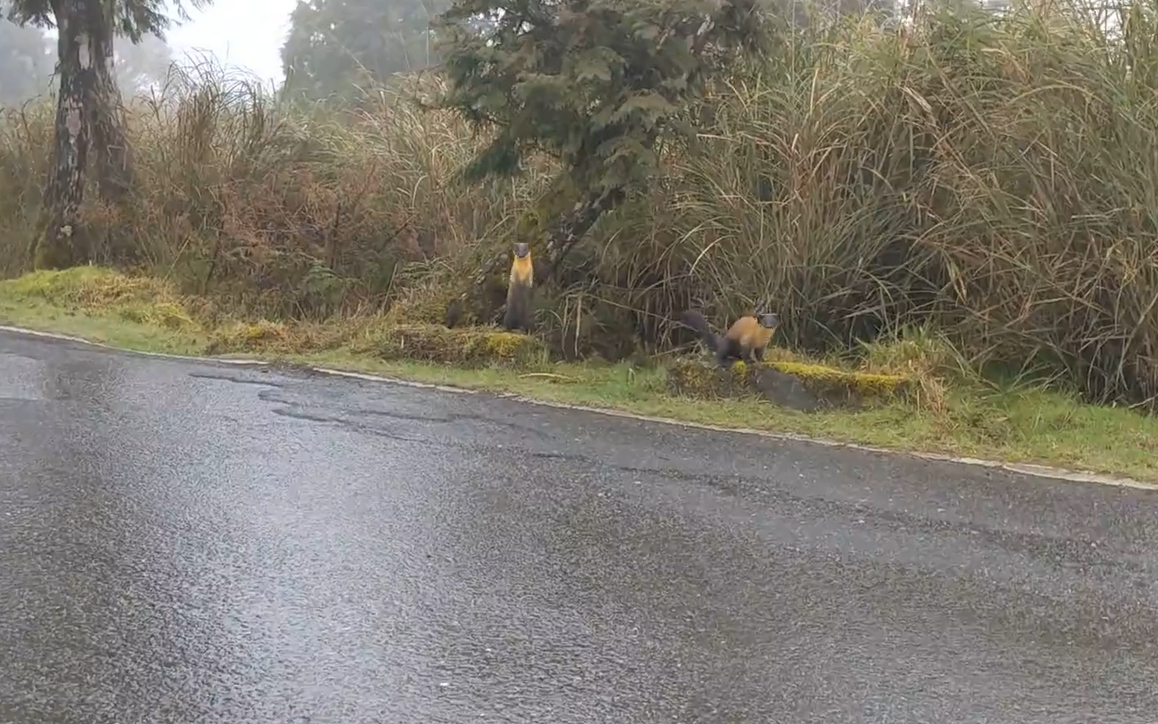

(10) 同(9)在CMD 執行 ffplay o.MP4，會出現影片播放，按esc結束後結果如下：
D:\>FFPLAY o.MP4
:
Input #0, mov,mp4,m4a,3gp,3g2,mj2, from 'o.MP4':B sq= 0B f=0/0
Metadata:
major_brand : isom
minor_version : 512
compatible_brands: isomiso2avc1mp41
encoder : Lavf59.16.100
Duration: 00:00:23.04, start: 0.000000, bitrate: 4534 kb/s
Stream #0:0[0x1](eng): Video: h264 (High) (avc1 / 0x31637661), yuvj420p(pc, progressive), 1920x1080 [SAR 1:1 DAR 16:9], 4274 kb/s, 59.94 fps, 59.94 tbr, 60k tbn (default)
Metadata:
handler_name : VideoHandler
vendor_id : [0][0][0][0]
Stream #0:1[0x2](eng): Audio: aac (LC) (mp4a / 0x6134706D), 48000 Hz, stereo, fltp, 246 kb/s (default)
Metadata:
handler_name : SoundHandler
vendor_id : [0][0][0][0]
:
D:\>

常用指令用法參考文章：https://lnpcd.blogspot.com/2012/09/ffmpeg.html

